Virtual permits adding/changing vehicles
To add another vehicle to your permit and change the vehicle registration

To add another vehicle to your permit click on my permits and click in the car icon

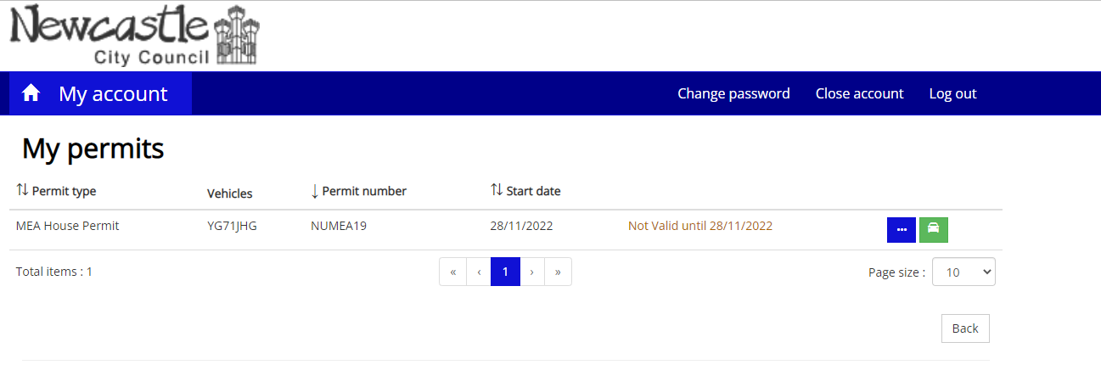
Click add vehicle
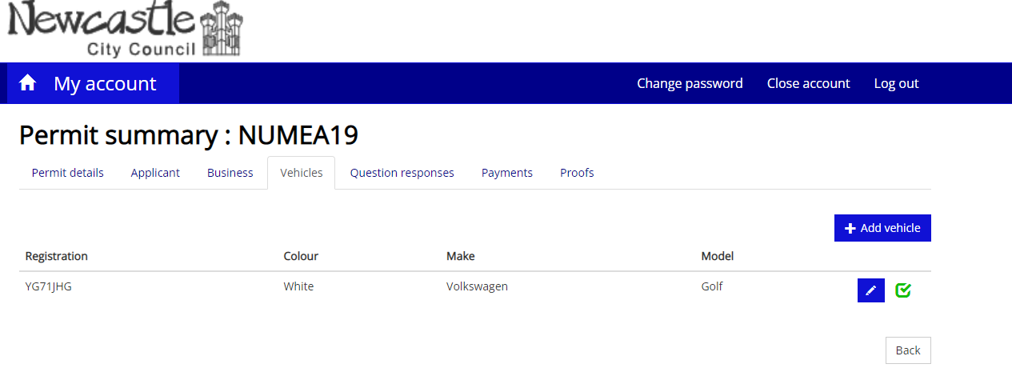You can then enter details of the vehicle you wish to add to your permit and click save. The vehicle details will now appear in the permit summary.
You can have a maximum of 3 registrations on your account.
The green tick against the vehicle shows the registration that is currently live on the permit.
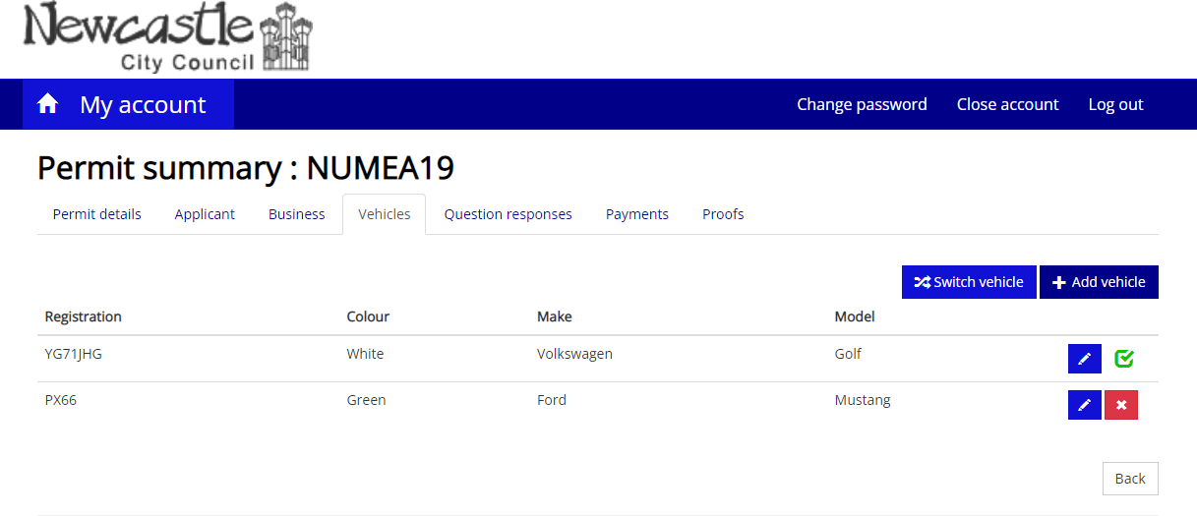

If you wish to change which vehicle is live on the permit click switch vehicle

select the registration you require and click save, you will see that the green tick is now against this registration.

To remove a registration click on the red cross next to the registration you wish to remove

And click remove
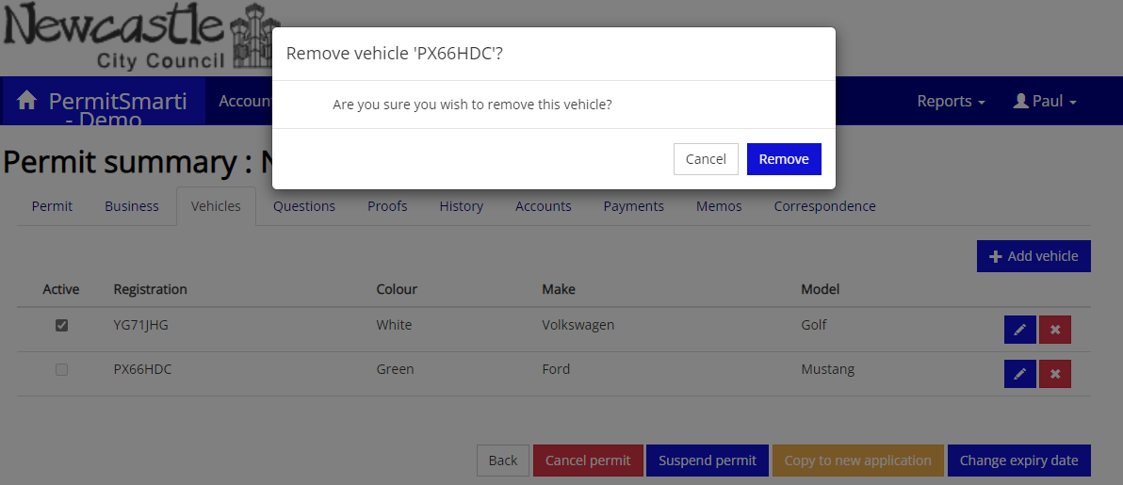
The registration has now been removed.

